Farlow’s Scientific Glassblowing, Inc.
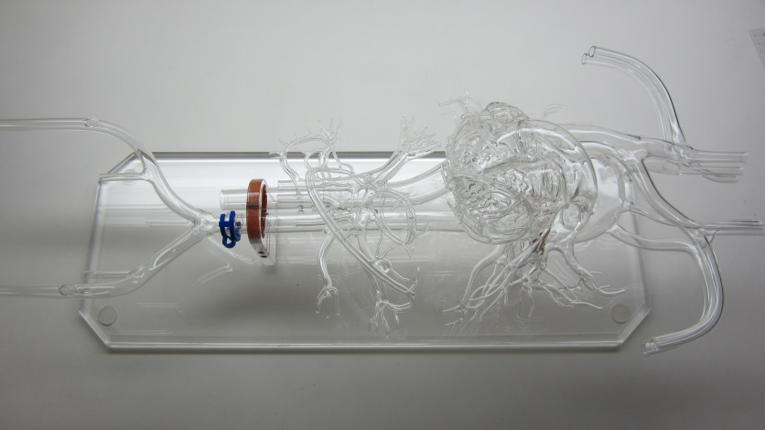
Anatomical Model Worksheet
Organ or region of anatomy to be modeled? ______________________________
Model sizing based on male, female or in between? _________________________
Model ends open for flow? _________ Barbed fittings? ____________________
If applicable:
Entry hole for catheter? ________ Location and size? ______________________
Removable iliac with ground joint? ______ Carotid arteries? _________________

Please further describe your unique requirements;

